VPrivCal Expert Review
  - Interface-aligned screening workbook for VPrivCal-Q10 and VPrivCal-Probe
Short workshop version for professional researchers
Decision / research question
Are the revised questions, implemented three-scene Probe interface and Hint walkthrough, workflow, and held-out evaluation sufficiently clear, actionable, low-burden, and safe to proceed to user cognitive interviews?

Method at a glance
Element | Current design
VPrivCal-Q10 | Ten direct policy questions; Q1-Q6 share one response scale.
VPrivCal-Probe | Three egocentric scenes spanning private, public, and semi-public contexts. After a required Hint walkthrough, participants mark areas without naming categories, then review each present internal category through neutral linked-content labels and optional evidence highlights.
Calibration target | Provisional pilot target: approximately 5-7 minutes total for Q10 plus Probe. Time the required Hint walkthrough separately and confirm the total empirically.
Effectiveness test | Generic versus Q10-only versus full compiled VPrivCal policy on manually verified held-out video windows.
Expert output | Keep/revise/remove decisions for Q10, Probe interface, Hint mode, stimuli, and held-out evaluation; pilot-readiness vote.

Version 6.1 | July 2026 | Interface-aligned edition

1. Reviewer instructions
Complete ratings independently before discussion. Use the expert-review interface, start each scene from a fresh state, and judge the visible design as implemented. Proposed fixes belong in the comment fields and should not inflate the current rating. The profile screen is currently disabled and is not participant-facing functionality.
Rating | Meaning
1 | Major problem / not ready
2 | Substantial revision needed
3 | Acceptable with minor revision
4 | Strong / ready for cognitive testing

2. Method workflow
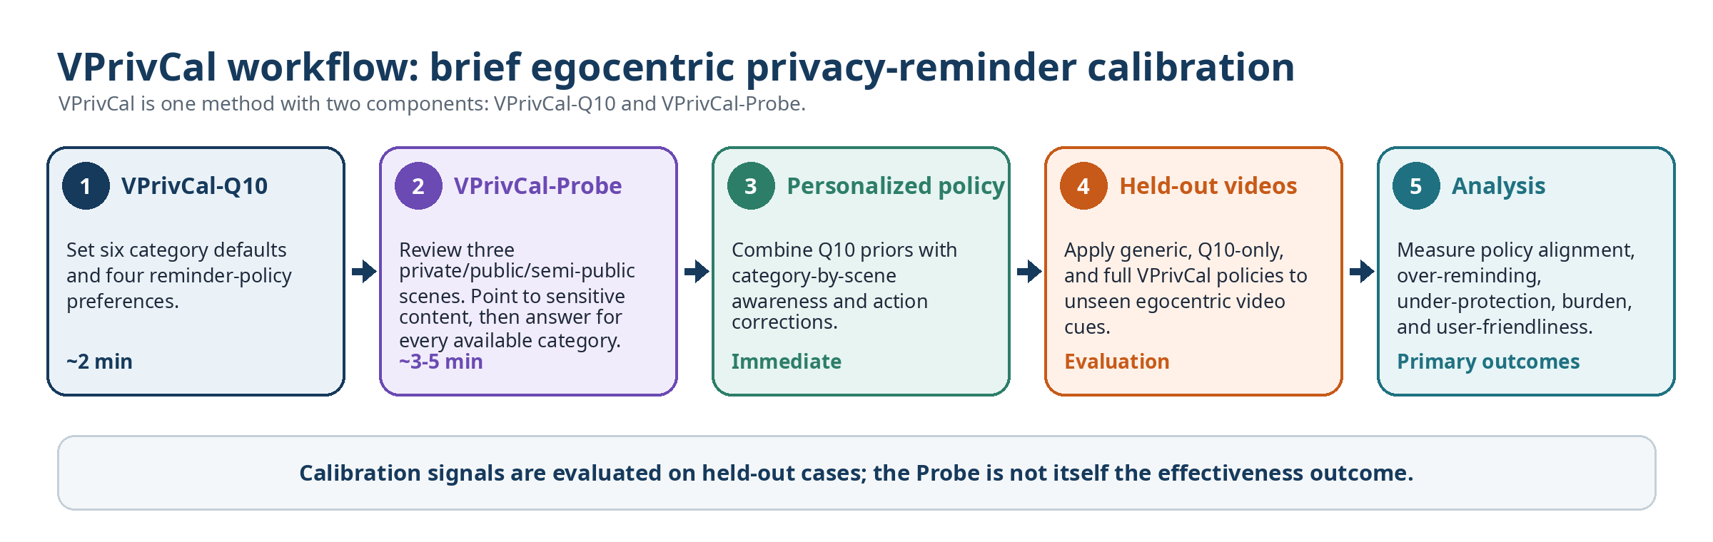
Review question | Rating / comment
Does the live workflow make clear that Q10 and Probe are two components of one method while the profile screen remains disabled? | 1 2 3 4 Comment: ______________________________
Is the 5-7 minute target credible when the required Hint walkthrough and category-complete review are included and timed separately? | 1 2 3 4 Comment: ______________________________
Is it clear that simulated policy-output pre-verification and held-out-video effectiveness testing occur after elicitation, not during the Probe? | 1 2 3 4 Comment: ______________________________

3. VPrivCal-Q10 candidate questions
Shared scale for Q1-Q6
1 Use for the current task without interruption | 2 Handle silently and avoid unnecessary detail | 3 Give a brief reminder | 4 Ask before using it | 5 Do not use it unless explicitly requested

Item | Category / policy dimension | Relevance | Clarity | Actionability | Predictive value | Decision
Q1 | Biometric data | 1 2 3 4 | 1 2 3 4 | 1 2 3 4 | 1 2 3 4 | Keep / Revise / Remove
Q2 | Children images | 1 2 3 4 | 1 2 3 4 | 1 2 3 4 | 1 2 3 4 | Keep / Revise / Remove
Q3 | Personally identifiable information (PII) | 1 2 3 4 | 1 2 3 4 | 1 2 3 4 | 1 2 3 4 | Keep / Revise / Remove
Q4 | Legal sensitivity information | 1 2 3 4 | 1 2 3 4 | 1 2 3 4 | 1 2 3 4 | Keep / Revise / Remove
Q5 | Personal life | 1 2 3 4 | 1 2 3 4 | 1 2 3 4 | 1 2 3 4 | Keep / Revise / Remove
Q6 | Background individuals | 1 2 3 4 | 1 2 3 4 | 1 2 3 4 | 1 2 3 4 | Keep / Revise / Remove
Q7 | Inferred privacy risks | 1 2 3 4 | 1 2 3 4 | 1 2 3 4 | 1 2 3 4 | Keep / Revise / Remove
Q8 | Reminder sensitivity | 1 2 3 4 | 1 2 3 4 | 1 2 3 4 | 1 2 3 4 | Keep / Revise / Remove
Q9 | Uncertain detections | 1 2 3 4 | 1 2 3 4 | 1 2 3 4 | 1 2 3 4 | Keep / Revise / Remove
Q10 | Task-irrelevant sensitive information | 1 2 3 4 | 1 2 3 4 | 1 2 3 4 | 1 2 3 4 | Keep / Revise / Remove

4. Item-specific prompts
Q1. Biometric data
Faces, fingerprints, and other distinctive body features that may identify a person.
Main concern / suggested wording: ______________________________________________________________
Q2. Children images
Children, school events, playgrounds, and child-related activities.
Main concern / suggested wording: ______________________________________________________________
Q3. Personally identifiable information (PII)
Financial or medical data; names, passports, email addresses, phone numbers, GPS, license plates, and other identifiers.
Main concern / suggested wording: ______________________________________________________________
Q4. Legal sensitivity information
Nudity or explicit imagery; violent or unlawful acts; criminal acts; weapons or other high-risk items.
Main concern / suggested wording: ______________________________________________________________
Q5. Personal life
Home interiors, personal items, location context, landmarks, routines, relationships, and activities.
Main concern / suggested wording: ______________________________________________________________
Q6. Background individuals
Passersby, bystanders, coworkers, patients, patrons, and other people incidentally captured.
Main concern / suggested wording: ______________________________________________________________
Q7. Inferred privacy risks
How should reminders work when the VLM can infer sensitive information that is not directly visible?
Main concern / suggested wording: ______________________________________________________________
Q8. Reminder sensitivity
What balance should the system use between missed risks and unnecessary reminders?
Main concern / suggested wording: ______________________________________________________________
Q9. Uncertain detections
What should happen when the VLM is unsure whether a cue is sensitive?
Main concern / suggested wording: ______________________________________________________________
Q10. Task-irrelevant sensitive information
What should happen when sensitive information is visible but unnecessary for the current task?
Main concern / suggested wording: ______________________________________________________________

5. VPrivCal-Probe stimuli
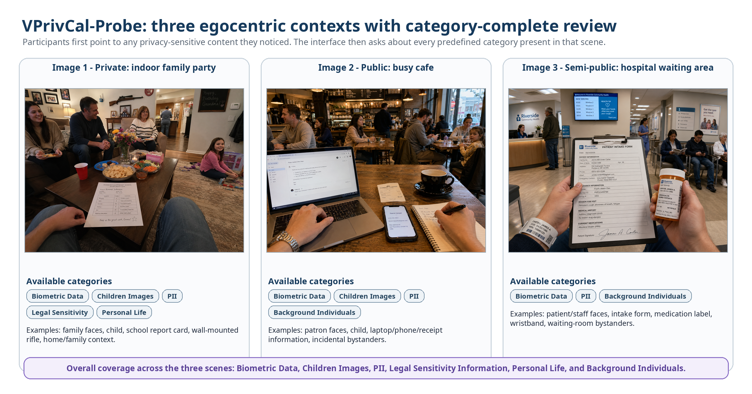
Two questions per internal category-scene pair
A. Before the highlight: already aware / noticed but did not consider privacy / did not notice or realize VLM capability / not a concern.
B. Preferred action for similar content: no intervention / silent handling / brief reminder / ask before use / avoid unless explicitly requested.
Category identities are hidden; participants see neutral linked-content labels.
The stimuli span private, public, and semi-public contexts. Coverage remains scene-level and internally category-complete across all six high-level categories. Phase A is unprompted pointing; Phase B uses neutral linked-content labels because participant-facing category identities are hidden.
Criterion | Scene 1 | Scene 2 | Scene 3 | Comment
Context is realistic and distinct | 1 2 3 4 | 1 2 3 4 | 1 2 3 4 | ________________
Internal category coverage is complete for the scene | 1 2 3 4 | 1 2 3 4 | 1 2 3 4 | ________________
The optional evidence highlight is correctly localized and understandable | 1 2 3 4 | 1 2 3 4 | 1 2 3 4 | ________________
The scene includes both obvious and subtle privacy content | 1 2 3 4 | 1 2 3 4 | 1 2 3 4 | ________________
Point-first marking and neutral linked-content review are usable | 1 2 3 4 | 1 2 3 4 | 1 2 3 4 | ________________
Cultural and ethical risk is acceptable | 1 2 3 4 | 1 2 3 4 | 1 2 3 4 | ________________
Implemented sequence: require the five-step Hint before the first scene (practice data are not saved; Hint time is separate). Phase A shows a clean image: participants place/delete points or confirm none; category/detection matching is internal, unmatched points are retained, and only ambiguous overlaps trigger a neutral chooser. Phase B reviews every present internal category sequentially with neutral linked-content labels, an optional Show/Hide highlight, awareness status, and preferred action. Category identities remain hidden.

6. Probe-level review
Review question | Rating | Comment
Does the required five-step Hint teach point, delete, phase transition, response layout, and next-item navigation without contaminating real answers? | 1 2 3 4 | ________________________
Is it clear that Hint data are not saved and Hint time is excluded from Probe completion time? | 1 2 3 4 | ________________________
Does Phase A preserve an interpretable unprompted signal when categories and detections remain hidden and unmatched points are retained? | 1 2 3 4 | ________________________
Are neutral linked-content labels plus the Show/Hide highlight sufficient to identify the review target without category names? | 1 2 3 4 | ________________________
Do the awareness-status and preferred-action items remain valid and sufficiently brief across every present internal category? | 1 2 3 4 | ________________________
Are pointer/delete, overlap chooser, move/zoom/pan/reset, keyboard controls, and list fallback sufficiently usable and accessible? | 1 2 3 4 | ________________________

7. Held-out evaluation review
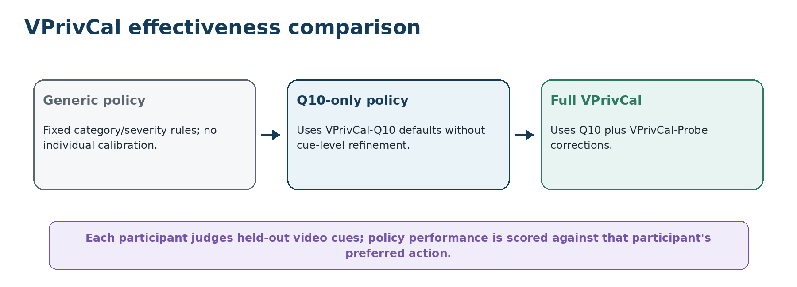
Metric / design decision | Expert judgment
Primary outcome: exact preferred-action alignment under counterbalanced policy conditions | Strong / Revise / Reject
Ordinal action error | Strong / Revise / Reject
Over-reminder and under-protection rates | Strong / Revise / Reject
Separate detection validity from privacy relevance | Strong / Revise / Reject
Use short, manually verified held-out egocentric video windows with temporally emerging cues | Strong / Revise / Reject
Simulated compiled-policy pre-verification before the pilot; label outputs non-empirical and keep them separate from the disabled profile UI | Strong / Revise / Reject

8. Final decision
VPrivCal-Q10: □ Proceed □ Minor revision □ Major revision □ Replace
VPrivCal-Probe interface (including Hint): □ Proceed □ Minor revision □ Major revision □ Replace
Workflow and held-out evaluation: □ Proceed □ Minor revision □ Major revision □ Replace
Simulated policy-output pre-verification: □ Proceed □ Minor revision □ Major revision □ Defer
Overall readiness for cognitive interviews: □ Yes □ Yes after revision □ No
Three highest-priority changes:
1. __________________________________________________________________________________
2. __________________________________________________________________________________
3. __________________________________________________________________________________
Alternative idea or missing test: ______________________________________________________________________

